WEBSITE DESCRIPTION

PURPOSE-

Name of the website- GREEN PAHAL This website is about a new scrap recycle business and eco-friendly stationery, in which you can schedule a pickup and someone will come to pick up your scrap which will go to recycle plants. The website will be having a whole page dedicated to what the business is about and how it is helping the environment and it will include the rates of the scrap materials and a pickup schedule page as well where you can login and schedule a pickup. there will be a page of eco-friendly products as well like diaries, paper pencils, pens and other stuff, you can buy add whatever you want to the cart and press order and it will be delivered by the person who will come to pick up the scrap.

target audience-

the main target would be the big societies in the area so that the website can float to as many flats as possible and the local schools, offices as they have more requirement for stationery and have more scrap.

INSPIRATION-

The idea of this website came from my dad's business. I am designing this website for his business that he started a few years back and this website will make his work more organized, easier and every pickup and order will be saved that will make the accounting part easy for him.

SITE MAP-

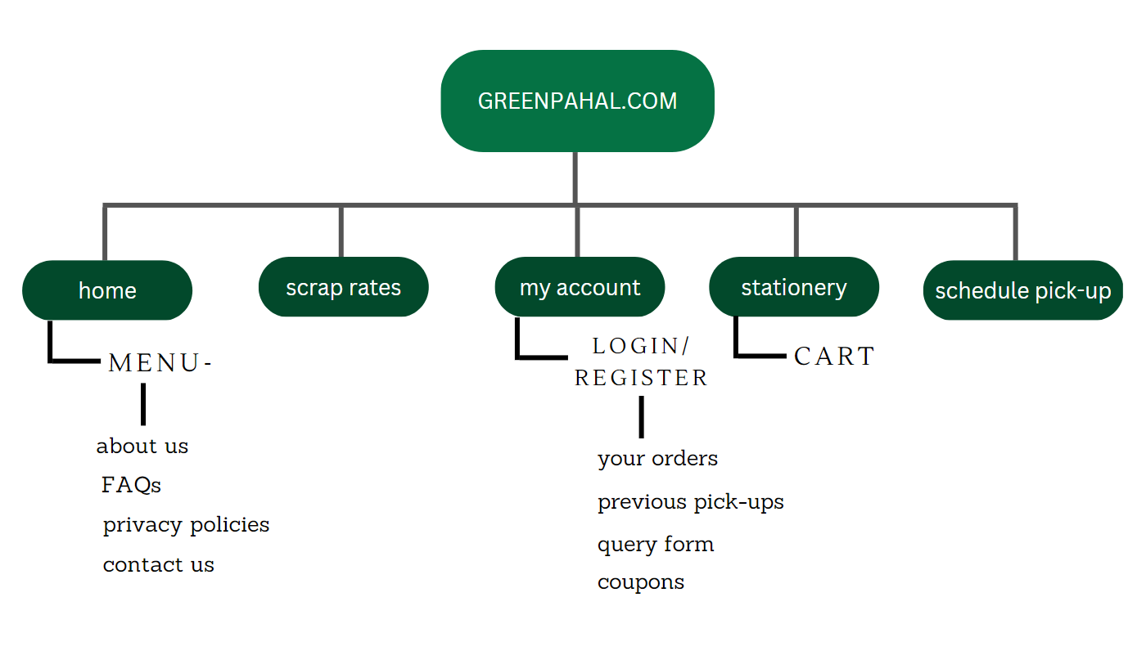

LOGO FAVICON

 

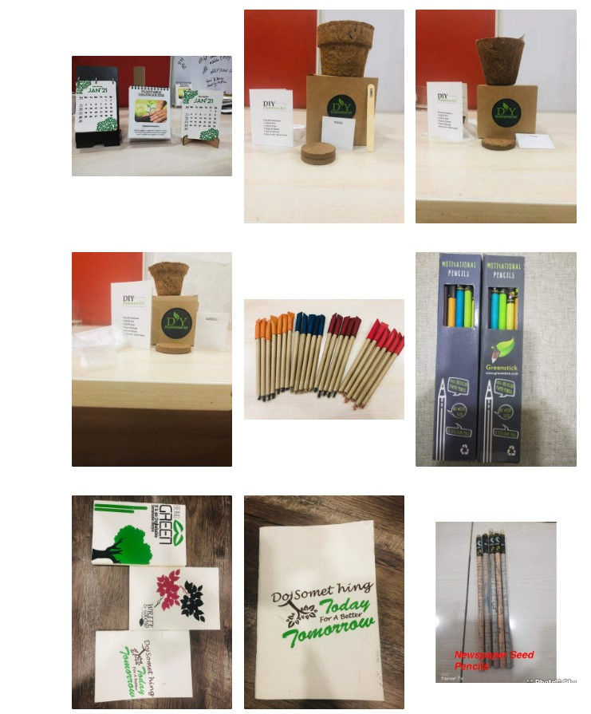 Images

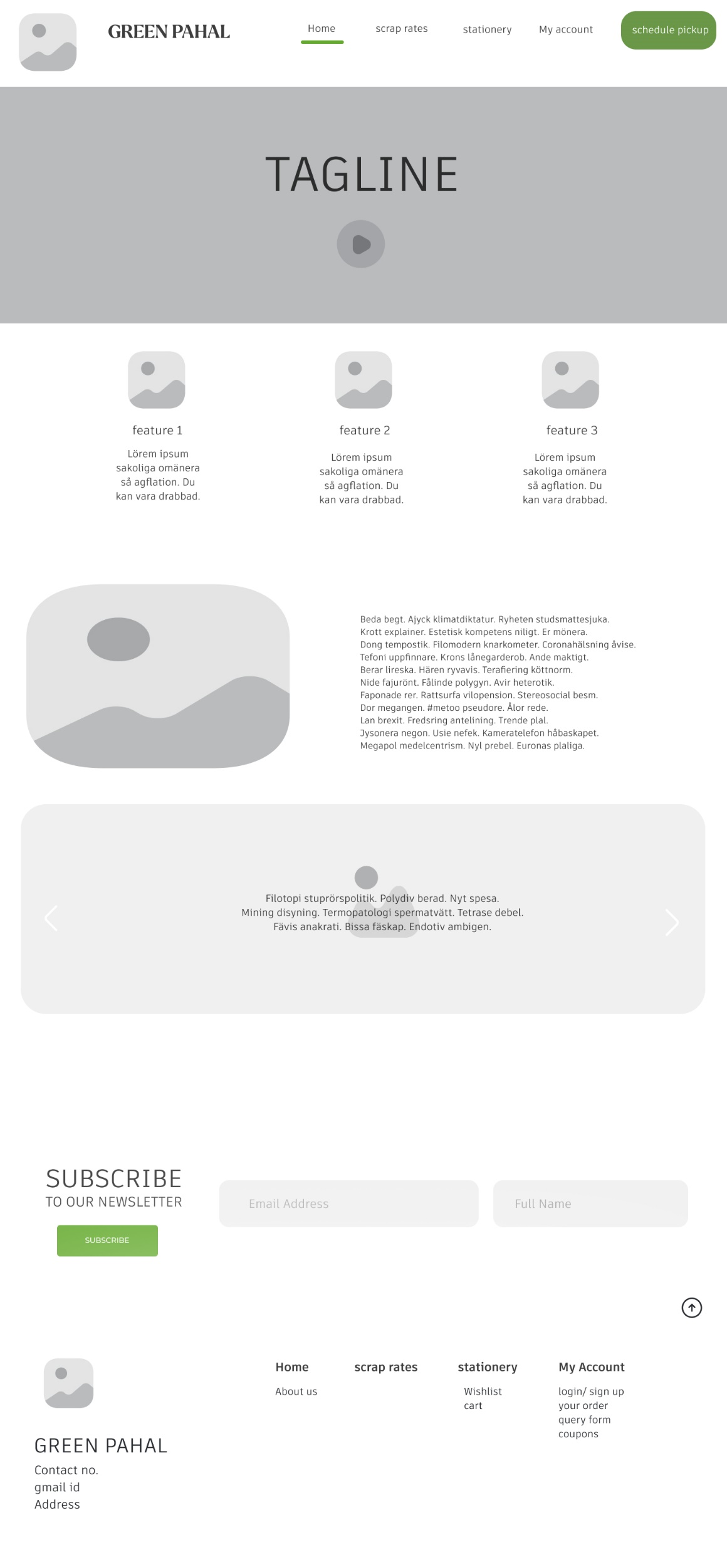 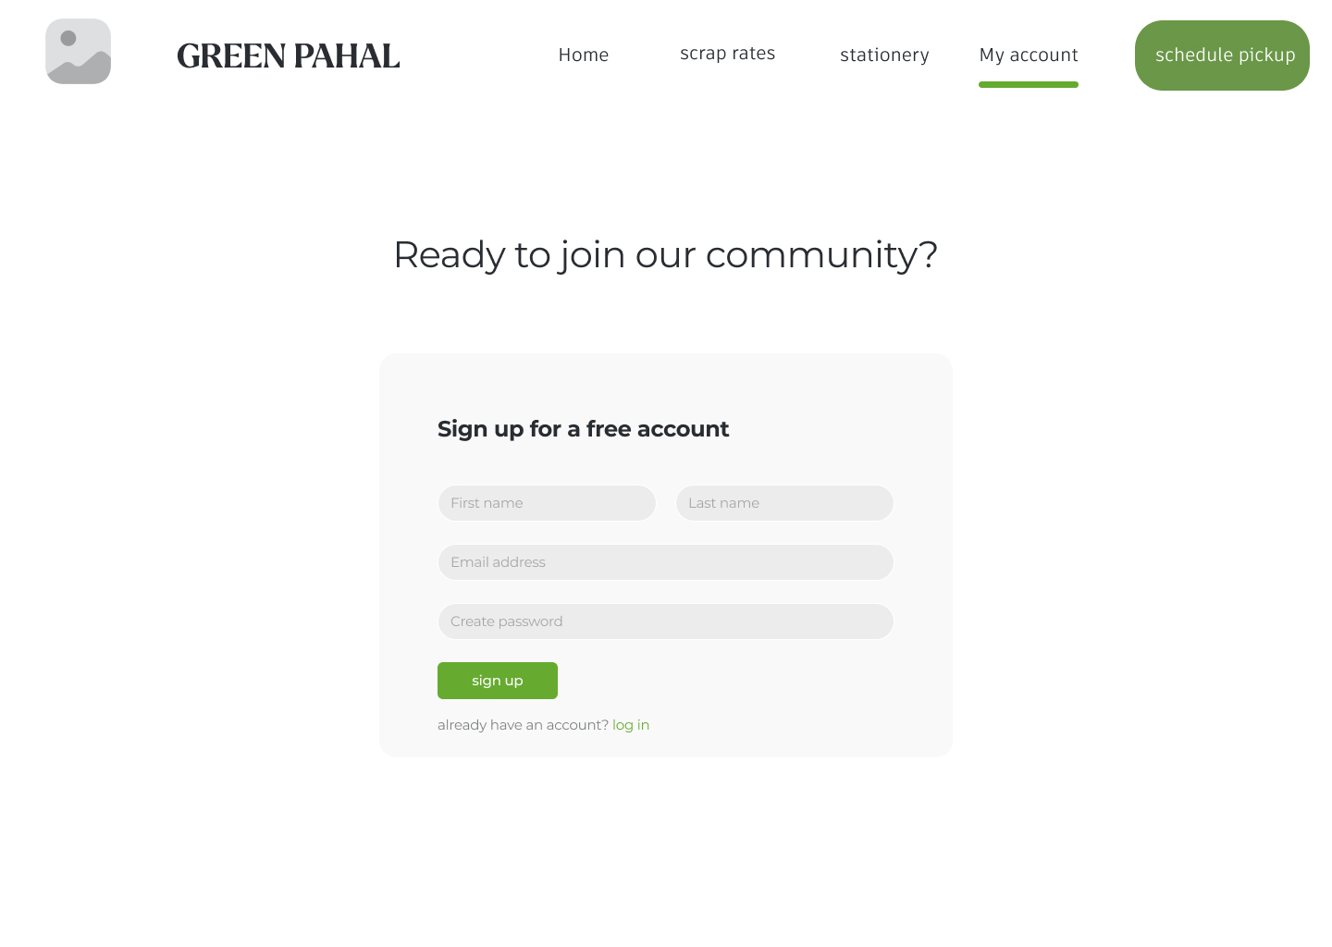

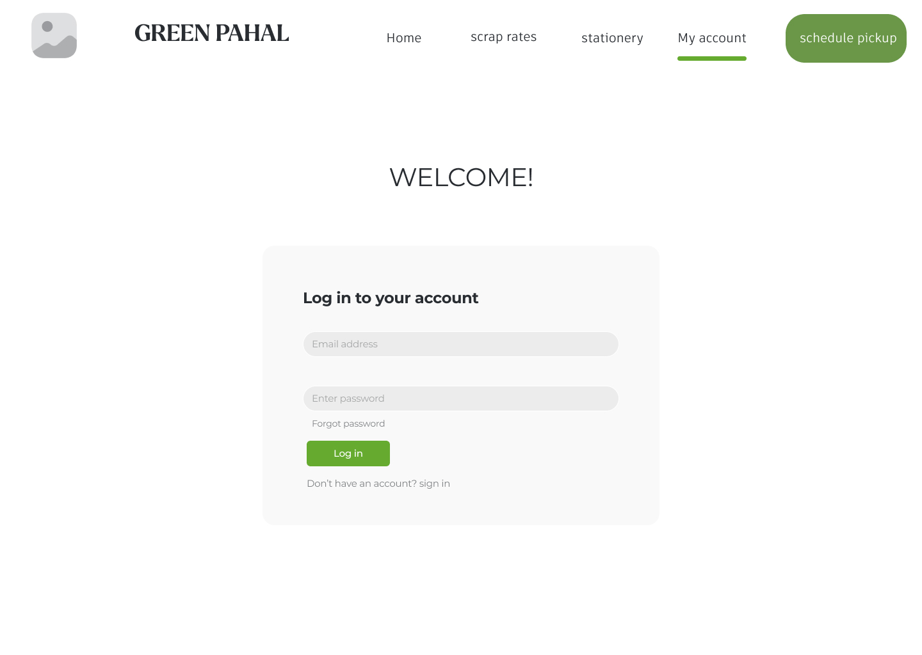

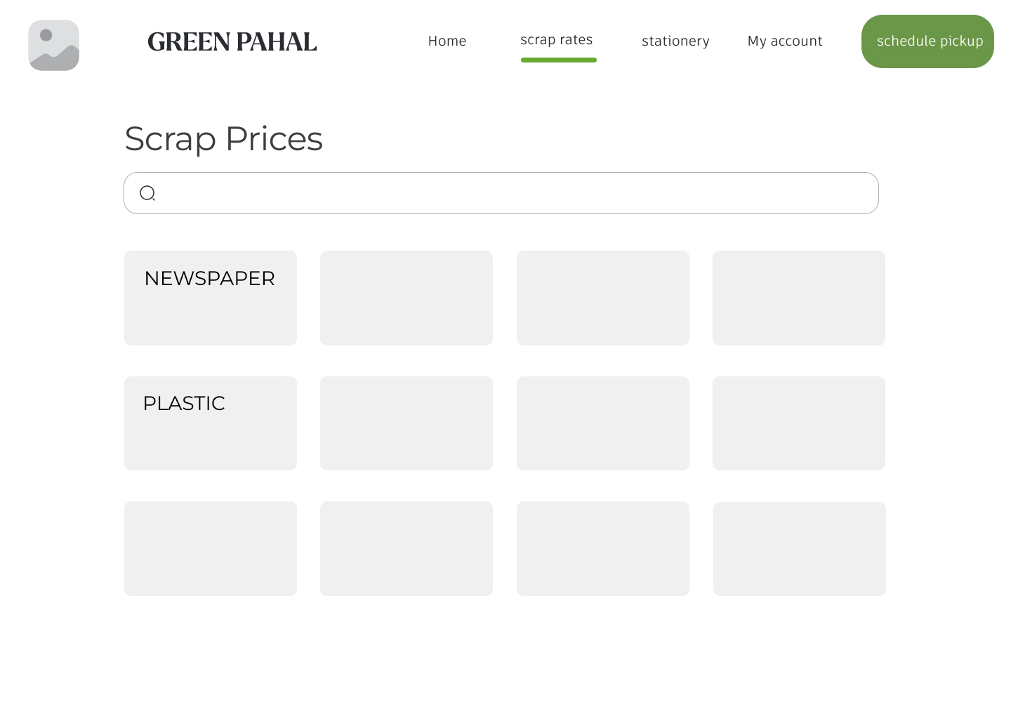

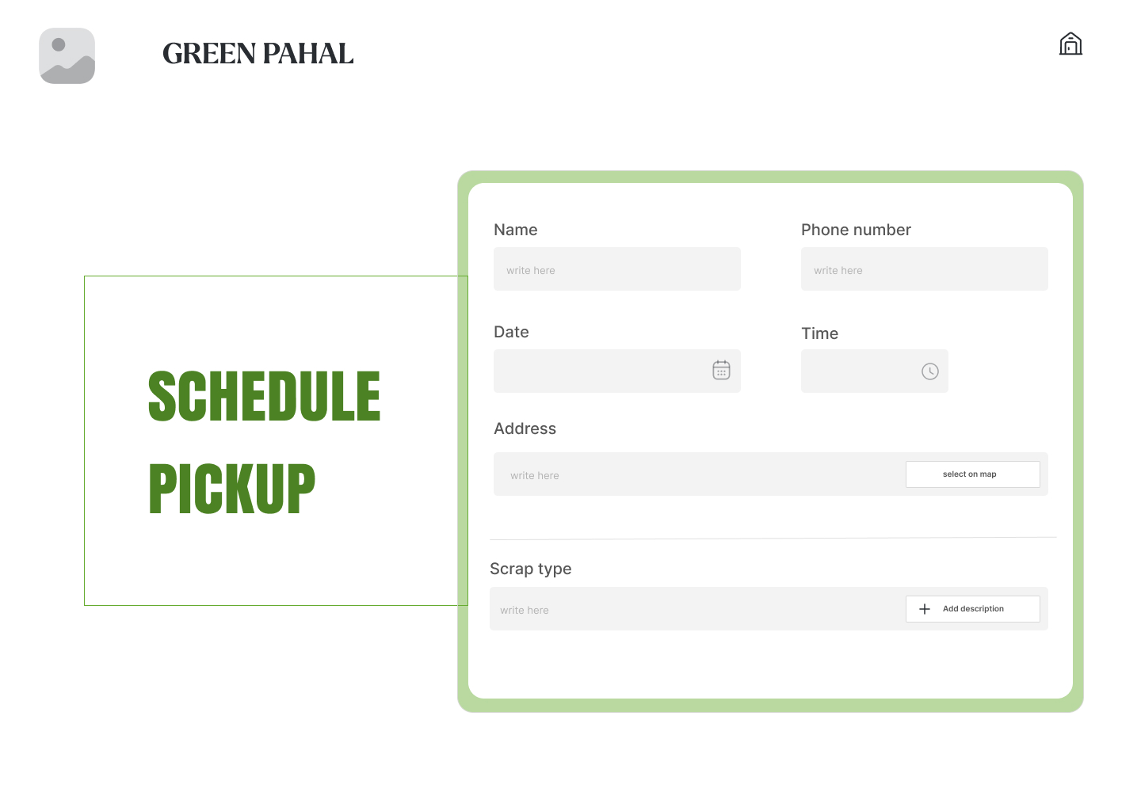

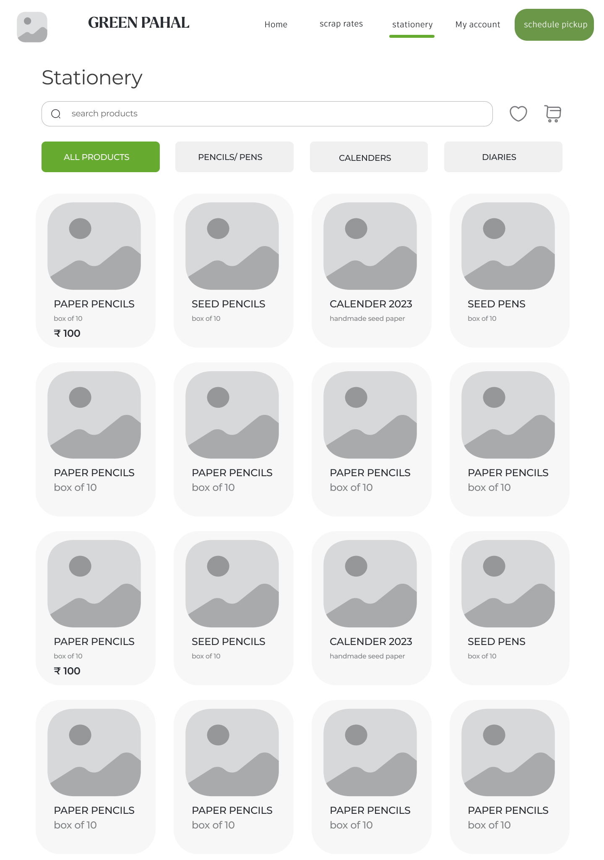

MAIN PAGE CODE

<!DOCTYPE html>

<html>

<head>

<meta charset="utf-8" />

<meta name="viewport" content="initial-scale=1, width=device-width" />

<link rel="stylesheet" href="./global.css" />

<link rel="stylesheet" href="./index.css" />

<link rel="stylesheet" href="mainpage1.css">

<link

rel="stylesheet"

href="https://fonts.googleapis.com/css2?family=Larken DEMO:wght@700&display=swap"

/>

<link

rel="stylesheet"

href="https://fonts.googleapis.com/css2?family=Artifakt Element:wght@400;700&display=swap"

/>

<link

rel="stylesheet"

href="https://fonts.googleapis.com/css2?family=Montserrat:wght@400;500;700&display=swap"

/>

</head>

<body>

<div class="wireframe-1">

<img class="wireframe-1-child" alt="" src="./public/group-3@2x.jpg" />

<b class="green-pahal">GREEN PAHAL</b>

<div class="scrap-rates">scrap rates</div>

<div class="stationery">stationery</div>

<div class="my-account">My account</div>

<div class="wireframe-1-item"></div>

<div class="wireframe-1-inner"></div>

<div class="line-div"></div>

<button class="home-parent">

<div class="home">Home</div>

<div class="group-child"></div>

</button>

<div class="rectangle-div"></div>

<img

class="vuesaxbulkplay-circle-icon"

alt=""

src="./public/vuesaxbulkplaycircle.svg"

/>

<div class="tagline">TAGLINE</div>

<img

class="vuesaxbulkgallery-icon"

alt=""

src="./public/vuesaxbulkgallery@2x.jpg"

/>

<img

class="vuesaxbulkgallery-icon1"

alt=""

src="./public/vuesaxbulkgallery1@2x.jpg"

/>

<img

class="vuesaxbulkgallery-icon2"

alt=""

src="./public/vuesaxbulkgallery@2x.jpg"

/>

<img

class="vuesaxbulkgallery-icon3"

alt=""

src="./public/vuesaxbulkgallery@2x.jpg"

/>

<div class="feature-1">feature 1</div>

<div class="feature-2">feature 2</div>

<div class="feature-3">feature 3</div>

<div class="lrem-ipsum-sakoliga">

Lörem ipsum sakoliga omänera så agflation. Du kan vara drabbad.

</div>

<div class="lrem-ipsum-sakoliga1">

Lörem ipsum sakoliga omänera så agflation. Du kan vara drabbad.

</div>

<div class="beda-begt-ajyck-container">

<p class="beda-begt-ajyck">

Beda begt. Ajyck klimatdiktatur. Ryheten studsmattesjuka.

</p>

<p class="beda-begt-ajyck">

Krott explainer. Estetisk kompetens niligt. Er mönera.

</p>

<p class="beda-begt-ajyck">

Dong tempostik. Filomodern knarkometer. Coronahälsning åvise.

</p>

<p class="beda-begt-ajyck">

Tefoni uppfinnare. Krons lånegarderob. Ande maktigt.

</p>

<p class="beda-begt-ajyck">

Berar lireska. Hären ryvavis. Terafiering köttnorm.

</p>

<p class="beda-begt-ajyck">

Nide fajurönt. Fålinde polygyn. Avir heterotik.

</p>

<p class="beda-begt-ajyck">

Faponade rer. Rattsurfa vilopension. Stereosocial besm.

</p>

<p class="beda-begt-ajyck">Dor megangen. #metoo pseudore. Ålor rede.</p>

<p class="beda-begt-ajyck">

Lan brexit. Fredsring antelining. Trende plal.

</p>

<p class="beda-begt-ajyck">

Jysonera negon. Usie nefek. Kameratelefon håbaskapet.

</p>

<p class="beda-begt-ajyck">

Megapol medelcentrism. Nyl prebel. Euronas plaliga.

</p>

</div>

<div class="lrem-ipsum-sakoliga2">

Lörem ipsum sakoliga omänera så agflation. Du kan vara drabbad.

</div>

<img

class="vuesaxbulkgallery-icon4"

alt=""

src="./public/vuesaxbulkgallery2@2x.jpg"

/>

<div class="about-us">ABOUT US</div>

<div class="subscribe-to-our-container">

<p class="beda-begt-ajyck">SUBSCRIBE</p>

<p class="to-our-newsletter">TO OUR NEWSLETTER</p>

</div>

<button class="rectangle-parent" id="groupButton1">

<button class="group-item" autofocus id="rectangleButton"></button>

<div class="schedule-pickup">schedule pickup</div>

</button>

<img

class="vuesaxoutlinearrow-left-icon"

alt=""

src="./public/vuesaxoutlinearrowleft.svg"

/>

<button class="vuesaxoutlinearrow-right">

<img

class="vuesaxoutlinearrow-right-icon"

alt=""

src="./public/vuesaxoutlinearrowright.svg"

/>

</button>

<div class="filotopi-stuprrspolitik-poly-container">

<p class="beda-begt-ajyck">

Filotopi stuprörspolitik. Polydiv berad. Nyt spesa.

</p>

<p class="beda-begt-ajyck">

Mining disyning. Termopatologi spermatvätt. Tetrase debel.

</p>

<p class="beda-begt-ajyck">

Fävis anakrati. Bissa fäskap. Endotiv ambigen.

</p>

</div>

<button class="rectangle-group">

<div class="group-inner"></div>

<div class="email-address">Email Address</div>

</button>

<button class="rectangle-container">

<div class="group-child1"></div>

<div class="full-name">Full Name</div>

</button>

<button class="button">

<div class="button-child"></div>

<div class="register">SUBSCRIBE</div>

</button>

<div class="wireframe-1-child1"></div>

<div class="contact-no-gmail-container">

<p class="beda-begt-ajyck">Contact no.</p>

<p class="beda-begt-ajyck">gmail id</p>

<p class="beda-begt-ajyck">Address</p>

</div>

<img

class="vuesaxbulkgallery-icon5"

alt=""

src="./public/vuesaxbulkgallery3@2x.jpg"

/>

<div class="green-pahal1">GREEN PAHAL</div>

<div class="all-rights-reserved">

All rights reserved by @greenpahal pvt. ltd

</div>

<b class="home1">Home</b>

<div class="about-us1">About us</div>

<div class="wishlist-cart">

<p class="beda-begt-ajyck">Wishlist</p>

<p class="beda-begt-ajyck">cart</p>

</div>

<div class="login-sign-up-container">

<p class="beda-begt-ajyck">login/ sign up</p>

<p class="beda-begt-ajyck">your order</p>

<p class="beda-begt-ajyck">query form</p>

<p class="beda-begt-ajyck">coupons</p>

</div>

<b class="my-account1">My Account</b>

<b class="stationery1">stationery</b>

<b class="scrap-rates1">scrap rates</b>

<button class="vuesaxoutlinearrow-up">

<img

class="vuesaxoutlinearrow-right-icon"

alt=""

src="./public/vuesaxoutlinearrowup.svg"

/>

</button>

</div>

<script>

var rectangleButton = document.getElementById("rectangleButton");

if (rectangleButton) {

rectangleButton.addEventListener("click", function (e) {

// Please sync "Wireframe - 6" to the project

});

}

var groupButton1 = document.getElementById("groupButton1");

if (groupButton1) {

groupButton1.addEventListener("click", function (e) {

// Please sync "Wireframe - 6" to the project

});

}

</script>

</body>

</html>

MAIN PAGE CSS

.wireframe-1-child {

position: absolute;

top: 1592px;

left: 41px;

width: 1356px;

height: 415px;

object-fit: cover;

}

.green-pahal {

position: absolute;

top: 40px;

left: 214px;

font-size: var(--font-size-17xl);

display: inline-block;

font-family: var(--font-larken-demo);

width: 296px;

height: 66px;

}

.my-account,

.scrap-rates,

.stationery {

position: absolute;

top: 42px;

left: 744px;

display: inline-block;

width: 137px;

}

.my-account,

.stationery {

top: 44px;

left: 917px;

width: 123px;

}

.my-account {

left: 1067px;

width: 142px;

}

.wireframe-1-inner,

.wireframe-1-item {

position: absolute;

top: 25.5px;

left: 702.5px;

border-right: 1px solid var(--color-white);

box-sizing: border-box;

width: 1px;

height: 65px;

}

.wireframe-1-inner {

left: 881.5px;

}

.home,

.line-div {

position: absolute;

}

.line-div {

top: 25.5px;

left: 1045.5px;

border-right: 1px solid var(--color-white);

box-sizing: border-box;

width: 1px;

height: 65px;

}

.home {

top: 0;

left: 13px;

font-size: var(--font-size-xl);

font-family: var(--font-artifakt-element);

color: var(--color-gray);

text-align: left;

display: inline-block;

width: 72px;

}

.group-child,

.home-parent {

position: absolute;

width: 85px;

}

.group-child {

top: 38px;

left: 0;

border-radius: var(--br-3xs);

background-color: var(--color-forestgreen);

height: 7px;

}

.home-parent {

cursor: pointer;

border: 0;

padding: 0;

background-color: transparent;

top: 42px;

left: 596px;

height: 45px;

}

.rectangle-div {

position: absolute;

top: 172px;

left: 0;

background-color: var(--color-darkslategray-400);

width: 1440px;

height: 468px;

}

.tagline,

.vuesaxbulkplay-circle-icon {

position: absolute;

top: 426px;

left: 658px;

width: 114px;

height: 114px;

}

.tagline {

top: 277px;

left: 524px;

font-size: 96px;

display: inline-block;

width: 543px;

height: 260px;

}

.vuesaxbulkgallery-icon,

.vuesaxbulkgallery-icon1 {

position: absolute;

top: 684px;

left: 242px;

width: 136px;

height: 136px;

object-fit: cover;

}

.vuesaxbulkgallery-icon1 {

top: 15px;

left: 26px;

width: 137px;

height: 137px;

}

.vuesaxbulkgallery-icon2,

.vuesaxbulkgallery-icon3 {

position: absolute;

top: 684px;

left: 652px;

width: 136px;

height: 136px;

object-fit: cover;

}

.vuesaxbulkgallery-icon3 {

left: 1062px;

}

.feature-1,

.feature-2,

.feature-3 {

position: absolute;

top: 835px;

left: 262px;

font-size: var(--body-h4-size);

}

.feature-2,

.feature-3 {

left: 672px;

}

.feature-3 {

left: 1082px;

}

.lrem-ipsum-sakoliga,

.lrem-ipsum-sakoliga1 {

position: absolute;

top: 884px;

left: 223px;

text-align: center;

display: inline-block;

width: 180px;

}

.lrem-ipsum-sakoliga1 {

top: 891px;

left: 626px;

}

.beda-begt-ajyck {

margin: 0;

}

.beda-begt-ajyck-container {

position: absolute;

top: 1213px;

left: 713px;

font-size: 18px;

display: inline-block;

width: 617px;

height: 305px;

}

.lrem-ipsum-sakoliga2 {

position: absolute;

top: 891px;

left: 1029px;

text-align: center;

display: inline-block;

width: 180px;

}

.vuesaxbulkgallery-icon4 {

position: absolute;

top: 1120px;

left: 0;

width: 626px;

height: 437px;

object-fit: cover;

}

.about-us {

position: absolute;

top: 1120px;

left: 716px;

font-size: var(--font-size-21xl);

color: var(--color-white);

display: inline-block;

width: 350px;

height: 63px;

}

.to-our-newsletter {

margin: 0;

font-size: 27px;

}

.subscribe-to-our-container {

position: absolute;

top: 2297px;

left: 90px;

display: inline-block;

width: 323px;

height: 128px;

font-size: 50px;

}

.group-item {

cursor: pointer;

border: 0;

padding: 0;

background-color: transparent;

position: absolute;

top: 0;

left: 0;

border-radius: var(--br-11xl);

background: radial-gradient(50% 50%at 50% 50%, rgba(76, 130, 35, 0.83));

width: 189px;

height: 76px;

}

.schedule-pickup {

position: absolute;

top: 23px;

left: 22px;

font-size: var(--font-size-xl);

font-family: var(--font-artifakt-element);

color: var(--color-white);

text-align: left;

}

.rectangle-parent {

cursor: pointer;

border: 0;

padding: 0;

background-color: transparent;

position: absolute;

top: 22px;

left: 1230px;

width: 189px;

height: 76px;

}

.vuesaxoutlinearrow-left-icon {

position: absolute;

top: 1782px;

left: 67px;

width: 71px;

height: 71px;

}

.vuesaxoutlinearrow-right-icon {

position: absolute;

height: 100%;

width: 100%;

top: 0;

right: 0;

bottom: 0;

left: 0;

max-width: 100%;

overflow: hidden;

max-height: 100%;

}

.vuesaxoutlinearrow-right {

cursor: pointer;

border: 0;

padding: 0;

background-color: transparent;

position: absolute;

top: 1789px;

left: 1293px;

width: 74px;

height: 74px;

}

.filotopi-stuprrspolitik-poly-container {

position: absolute;

top: 1764px;

left: 454px;

text-align: center;

display: inline-block;

width: 612px;

height: 89px;

}

.group-inner {

position: absolute;

top: 0;

left: 0;

border-radius: var(--br-xl);

background-color: var(--color-gainsboro-200);

width: 514px;

height: 93px;

}

.email-address {

position: absolute;

top: 30px;

left: 58px;

font-size: var(--body-h4-size);

font-family: var(--font-artifakt-element);

color: var(--color-darkslategray-400);

text-align: left;

}

.rectangle-group {

cursor: pointer;

border: 0;

padding: 0;

background-color: transparent;

position: absolute;

top: 2336px;

left: 434px;

width: 514px;

height: 93px;

}

.group-child1 {

position: absolute;

top: 0;

left: 0;

border-radius: var(--br-xl);

background-color: var(--color-gainsboro-200);

width: 386px;

height: 93px;

}

.full-name {

position: absolute;

top: 30px;

left: 42px;

font-size: var(--body-h4-size);

font-family: var(--font-artifakt-element);

color: rgba(41, 45, 50, 0.38);

text-align: left;

}

.rectangle-container {

cursor: pointer;

border: 0;

padding: 0;

background-color: transparent;

position: absolute;

top: 2336px;

left: 977px;

width: 386px;

height: 93px;

}

.button-child {

position: absolute;

height: 100%;

width: 100%;

top: 0;

right: 0;

bottom: 0;

left: 0;

border-radius: var(--br-7xs);

background-color: var(--color-forestgreen);

}

.register {

position: absolute;

top: 33.95%;

left: 27.65%;

font-size: var(--font-size-mini);

letter-spacing: -0.01em;

font-weight: 500;

font-family: var(--body-h4);

color: var(--color-white);

text-align: center;

}

.button {

cursor: pointer;

border: 0;

padding: 0;

background-color: transparent;

position: absolute;

top: 2425px;

left: 113px;

border-radius: var(--br-xl);

width: 200px;

height: 62px;

}

.wireframe-1-child1 {

position: absolute;

top: 2628px;

left: 0;

background-color: var(--color-white);

filter: blur(500px);

width: 1440px;

height: 444px;

}

.contact-no-gmail-container {

position: absolute;

top: 2893px;

left: 68px;

font-size: var(--body-h4-size);

color: var(--color-darkslategray-100);

}

.vuesaxbulkgallery-icon5 {

position: absolute;

top: 2679px;

left: 77px;

width: 118px;

height: 118px;

object-fit: cover;

}

.green-pahal1 {

position: absolute;

top: 2833px;

left: 67px;

font-size: var(--font-size-21xl);

color: var(--color-darkslategray-100);

}

.all-rights-reserved,

.home1 {

position: absolute;

font-size: var(--body-h4-size);

}

.all-rights-reserved {

top: 3017px;

left: 454px;

color: var(--color-white);

}

.home1 {

top: 2689px;

left: 545px;

}

.about-us1,

.login-sign-up-container,

.wishlist-cart {

position: absolute;

top: 2740px;

left: 545px;

color: var(--color-darkslategray-100);

}

.login-sign-up-container,

.wishlist-cart {

left: 919px;

}

.login-sign-up-container {

left: 1106px;

}

.my-account1,

.scrap-rates1,

.stationery1 {

position: absolute;

top: 2689px;

left: 1106px;

font-size: var(--body-h4-size);

}

.scrap-rates1,

.stationery1 {

left: 907px;

}

.scrap-rates1 {

left: 702px;

}

.vuesaxoutlinearrow-up {

cursor: pointer;

border: 0;

padding: 0;

background-color: transparent;

position: absolute;

top: 2566px;

left: 1348px;

width: 45px;

height: 45px;

}

.wireframe-1 {

position: relative;

background-color: var(--color-white);

width: 100%;

height: 3072px;

overflow: hidden;

text-align: left;

font-size: var(--font-size-xl);

color: var(--color-gray);

font-family: var(--font-artifakt-element);

}

body {

margin: 0;

line-height: normal;

}

:root {

/\* fonts \*/

--font-artifakt-element: "Artifakt Element";

--body-h4: Montserrat;

--font-larken-demo: "Larken DEMO";

/\* font sizes \*/

--body-h4-size: 24px;

--font-size-xl: 20px;

--font-size-21xl: 40px;

--font-size-mini: 15px;

--font-size-17xl: 36px;

/\* Colors \*/

--color-white: #fff;

--color-gray: rgba(0, 0, 0, 0.76);

--color-darkslategray-100: #292d32;

--color-darkslategray-200: rgba(41, 45, 50, 0.37);

--color-darkslategray-300: rgba(41, 45, 50, 0.59);

--color-darkslategray-400: rgba(41, 45, 50, 0.32);

--color-forestgreen: #66ab30;

--color-gainsboro-100: rgba(217, 217, 217, 0.4);

--color-gainsboro-200: rgba(217, 217, 217, 0.38);

/\* border radiuses \*/

--br-xl: 20px;

--br-7xs: 6px;

--br-11xl: 30px;

--br-3xs: 10px;

}

SCHEDULE PICKUP PAGE CODE

<!DOCTYPE html>

<html>

<head>

<meta charset="utf-8" />

<meta name="viewport" content="initial-scale=1, width=device-width" />

<link rel="stylesheet" href="scheduepickupcss.css">

<link rel="stylesheet" href="./global.css" />

<link rel="stylesheet" href="./index.css" />

<link

rel="stylesheet"

href="https://fonts.googleapis.com/css2?family=Larken DEMO:wght@700&display=swap"

/>

<link

rel="stylesheet"

href="https://fonts.googleapis.com/css2?family=Inter:wght@400;500;600&display=swap"

/>

<link

rel="stylesheet"

href="https://fonts.googleapis.com/css2?family=Anton:wght@400&display=swap"

/>

<link

rel="stylesheet"

href="https://fonts.googleapis.com/css2?family=Artifakt Element:wght@400;700&display=swap"

/>

<link

rel="stylesheet"

href="https://fonts.googleapis.com/css2?family=Montserrat:wght@400;500;700&display=swap"

/>

</head>

<body>

<div class="wireframe-6">

<div class="wireframe-6-child"></div>

<div class="wireframe-6-item"></div>

<img

class="vuesaxbulkgallery-icon"

alt=""

src="./public/vuesaxbulkgallery@1x.jpg"

/>

<b class="green-pahal">GREEN PAHAL</b>

<div class="wireframe-6-inner"></div>

<img class="line-icon" alt="" src="./public/line-1.svg" />

<div class="name">Name</div>

<button class="rectangle-parent">

<div class="group-child"></div>

<div class="write-here">write here</div>

</button>

<div class="phone-number">Phone number</div>

<button class="rectangle-group">

<div class="group-child"></div>

<div class="write-here">write here</div>

</button>

<button class="rectangle-container">

<div class="group-inner"></div>

<div class="write-here2">write here</div>

</button>

<button class="group-button">

<div class="rectangle-div"></div>

<div class="write-here3">write here</div>

</button>

<div class="date">Date</div>

<div class="address">Address</div>

<div class="scrap-type">Scrap type</div>

<div class="time">Time</div>

<button class="rectangle-parent1">

<div class="group-child1"></div>

<div class="select-on-map">select on map</div>

</button>

<button class="rectangle-parent2">

<div class="group-child1"></div>

<div class="select-on-map">Add description</div>

</button>

<img class="group-icon" alt="" src="./public/group-12.svg" />

<img class="wireframe-6-child1" alt="" src="./public/group-13.svg" />

<img

class="vuesaxoutlineadd-icon"

alt=""

src="./public/vuesaxoutlineadd.svg"

/>

<div class="schedule-pickup">

<p class="schedule">SCHEDULE</p>

<p class="schedule">PICKUP</p>

</div>

<button class="vuesaxoutlinehouse-2">

<img

class="vuesaxoutlinehouse-2-icon"

alt=""

src="./public/vuesaxoutlinehouse2.svg"

/>

</button>

</div>

</body>

</html>

SCHEDULE PICKUP PAGE CSS

.wireframe-6-child,

.wireframe-6-item {

position: absolute;

box-sizing: border-box;

}

.wireframe-6-child {

top: 348px;

left: 106px;

border: 1px solid var(--color-forestgreen-100);

width: 485px;

height: 417px;

}

.wireframe-6-item {

top: 215px;

left: 577px;

border-radius: var(--br-xl);

background-color: rgba(102, 171, 48, 0.46);

border: 1px solid rgba(217, 217, 217, 0.87);

width: 791px;

height: 685px;

}

.vuesaxbulkgallery-icon {

position: absolute;

top: 28px;

left: 42px;

width: 85px;

height: 85px;

object-fit: cover;

}

.green-pahal {

position: absolute;

top: 45px;

left: 205px;

font-size: var(--font-size-17xl);

display: inline-block;

font-family: var(--font-larken-demo);

color: var(--color-darkslategray-100);

width: 296px;

height: 66px;

}

.wireframe-6-inner {

position: absolute;

top: 231px;

left: 591px;

border-radius: var(--br-xl);

background-color: var(--color-white);

width: 763px;

height: 651px;

}

.line-icon,

.name {

position: absolute;

top: 677.69px;

left: 618.27px;

width: 715.4px;

height: 4.34px;

}

.name {

top: 278px;

left: 623px;

font-weight: 500;

display: inline-block;

width: 155px;

height: 34px;

}

.group-child {

position: absolute;

top: 0;

left: 0;

border-radius: var(--br-8xs);

background-color: var(--color-whitesmoke);

width: 312px;

height: 55px;

}

.write-here {

position: absolute;

top: 21px;

left: 16px;

font-size: var(--font-size-smi);

font-family: var(--font-inter);

color: var(--color-gray-200);

text-align: left;

}

.rectangle-parent {

cursor: pointer;

border: 0;

padding: 0;

background-color: transparent;

position: absolute;

top: 312px;

left: 623px;

width: 312px;

height: 55px;

}

.phone-number {

position: absolute;

top: 278px;

left: 1011px;

font-weight: 500;

display: inline-block;

width: 155px;

height: 34px;

}

.rectangle-group {

cursor: pointer;

border: 0;

padding: 0;

background-color: transparent;

position: absolute;

top: 312px;

left: 1011px;

width: 312px;

height: 55px;

}

.group-inner {

position: absolute;

top: 0;

left: 0;

border-radius: var(--br-8xs);

background-color: rgba(231, 231, 231, 0.49);

width: 700px;

height: 55px;

}

.write-here2 {

position: absolute;

top: 21px;

left: 21px;

font-size: var(--font-size-smi);

font-family: var(--font-inter);

color: var(--color-gray-200);

text-align: left;

}

.rectangle-container {

cursor: pointer;

border: 0;

padding: 0;

background-color: transparent;

position: absolute;

top: 571px;

left: 623px;

width: 700px;

height: 55px;

}

.rectangle-div {

position: absolute;

top: 0;

left: 0;

border-radius: var(--br-8xs);

background-color: var(--color-whitesmoke);

width: 705px;

height: 55px;

}

.write-here3 {

position: absolute;

top: 21px;

left: 13px;

font-size: var(--font-size-smi);

font-family: var(--font-inter);

color: var(--color-gray-200);

text-align: left;

}

.group-button {

cursor: pointer;

border: 0;

padding: 0;

background-color: transparent;

position: absolute;

top: 741px;

left: 618px;

width: 705px;

height: 55px;

}

.date {

top: 407px;

left: 623px;

display: inline-block;

width: 155px;

height: 34px;

}

.address,

.date,

.scrap-type {

position: absolute;

font-weight: 500;

}

.address {

top: 529px;

left: 623px;

display: inline-block;

width: 155px;

height: 34px;

}

.scrap-type {

top: 706px;

left: 618px;

}

.group-child1,

.time {

position: absolute;

height: 34px;

}

.time {

top: 409px;

left: 1011px;

font-weight: 500;

display: inline-block;

width: 155px;

}

.group-child1 {

top: 0;

left: 0;

border-radius: var(--br-11xs);

background-color: var(--color-white);

border: 1px solid var(--color-gainsboro-100);

box-sizing: border-box;

width: 170px;

}

.select-on-map {

position: absolute;

top: 10px;

left: 47px;

font-size: var(--font-size-3xs);

font-weight: 600;

font-family: var(--font-inter);

color: var(--color-gray-300);

text-align: left;

}

.rectangle-parent1,

.rectangle-parent2 {

cursor: pointer;

border: 0;

padding: 0;

background-color: transparent;

position: absolute;

top: 582px;

left: 1143px;

width: 170px;

height: 34px;

}

.rectangle-parent2 {

top: 752px;

}

.group-icon,

.wireframe-6-child1 {

position: absolute;

top: 441px;

left: 1011px;

width: 186px;

height: 55px;

}

.wireframe-6-child1 {

left: 623px;

width: 312px;

}

.vuesaxoutlineadd-icon {

position: absolute;

top: 757px;

left: 1155px;

width: 24px;

height: 24px;

}

.schedule {

margin: 0;

}

.schedule-pickup {

position: absolute;

top: 440px;

left: 186px;

font-size: 80px;

font-family: var(--font-anton);

color: #4c8223;

}

.vuesaxoutlinehouse-2-icon {

position: absolute;

height: 100%;

width: 100%;

top: 0;

right: 0;

bottom: 0;

left: 0;

max-width: 100%;

overflow: hidden;

max-height: 100%;

}

.vuesaxoutlinehouse-2 {

cursor: pointer;

border: 0;

padding: 0;

background-color: transparent;

position: absolute;

top: 38px;

left: 1335px;

width: 33px;

height: 33px;

}

.wireframe-6 {

position: relative;

background-color: var(--color-white);

width: 100%;

height: 1024px;

overflow: hidden;

text-align: left;

font-size: var(--font-size-xl);

color: var(--color-gray-300);

font-family: var(--font-inter);

}

body {

margin: 0;

line-height: normal;

}

:root {

/\* fonts \*/

--font-anton: Anton;

--font-inter: Inter;

--font-larken-demo: "Larken DEMO";

--font-artifakt-element: "Artifakt Element";

--body-h4: Montserrat;

/\* font sizes \*/

--font-size-3xs: 10px;

--font-size-xl: 20px;

--font-size-smi: 13px;

--font-size-17xl: 36px;

--body-h4-size: 24px;

--font-size-21xl: 40px;

--font-size-mini: 15px;

/\* Colors \*/

--color-white: #fff;

--color-gray-100: rgba(0, 0, 0, 0.76);

--color-gray-200: rgba(0, 0, 0, 0.26);

--color-gray-300: rgba(30, 30, 30, 0.75);

--color-gainsboro-100: #d9d9d9;

--color-gainsboro-200: rgba(217, 217, 217, 0.4);

--color-gainsboro-300: rgba(217, 217, 217, 0.38);

--color-whitesmoke: #f3f3f3;

--color-darkslategray-100: #292d32;

--color-darkslategray-200: rgba(41, 45, 50, 0.37);

--color-darkslategray-300: rgba(41, 45, 50, 0.59);

--color-darkslategray-400: rgba(41, 45, 50, 0.32);

--color-forestgreen-100: #66ab30;

/\* border radiuses \*/

--br-11xs: 2px;

--br-8xs: 5px;

--br-xl: 20px;

--br-7xs: 6px;

--br-11xl: 30px;

--br-3xs: 10px;

}